**Skilled Based Credit Course**

**Project On**

**E-Ayurvedic Herbs**

**T. Y. B.Tech Information Technology**

**Problem Statement**

There are many quick Allopathy treatments are available now a days to prevent a disease or to keep ourselves away from diseases. But many times due to chemicals used in these allopathy medicines there are many side effects. So to preserve health and wellness by keeping the mind, body and spirit in balance & preventing disease rather than treating it, is much important. So now here Ayurveda plays an important role. Ayurveda is a traditional Indian system of medicines. Ayurveda is a healthy lifestyle system that people in India have used for more than 5000 years. Ayurvedic Herbs are also an important component of this approach. They are thought to protect our body from diseases and offer a variety of health benefits, including improved physical and mental health.

**Solution Overview**

A website will be developed to store the information of many types of Ayurvedic herbs. Where every needy person can search the website and get the information about many Ayurvedic herbs at a one place. This website provides a online platform to diseased as well as healthy peoples where they can search a detailed information about the needed herbs.

**Reqirements**

**Functional Requirements ::**

1.As a user , i should be able to open the website sucessfully

2.As a user , i should be able to search about plants

3.As a user , i should be able to read the information of plants place wise

4.As a user , i should be able to submit feedback form about information of ayurvedic plants

5.As a admin, i should be able to register my website in the system

6.As a admin, i should be able to view all the suggestions

7.As a admin, i should be able to update the information time to time

8.As a admin, i should be able to improve my website design as per the feedback

**Non-Functional Requirements ::**

1.security::

The system should be protected from top security attacks

2. Correctness:

website should be able to correctly show the information of ayurvedic medicinal plants placewise.

**System Design**

**Front End Class Diagram**

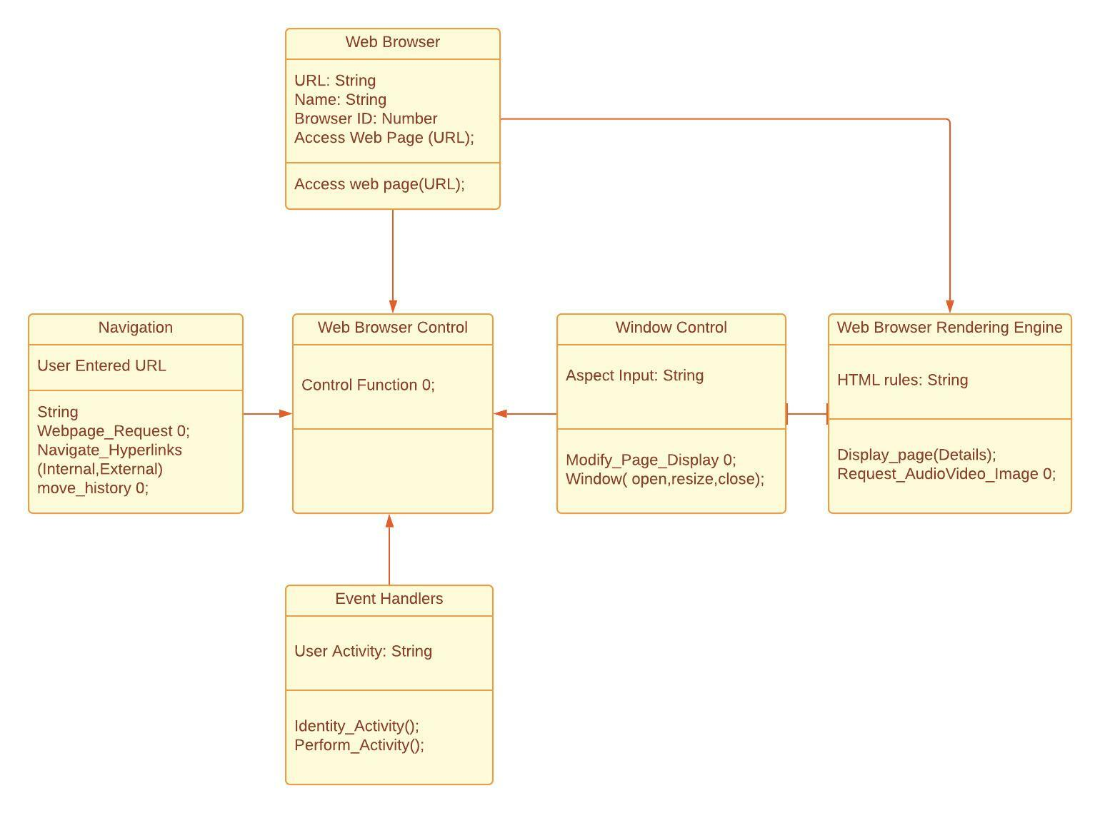

**Sequence Diagram**

